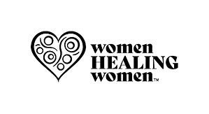
Women Healing Women

The Woman Healing Woman (WHW) Initiative is a transformative movement providing support, inspiration, and connection for women with metastatic cancer. Stemming from a personal journey of being widowed, orphaned, and diagnosed with stage 4 metastatic ovarian cancer in 2020, the initiative aims to create a sanctuary of healing and empowerment. Collaborating with organizations like the Alvarado Project, the Bay Area Cancer Community Organization, LGBTQ SF, and the American Cancer Society, it unites diverse communities in a shared mission of support. Led by co-founder Dr. Dorete Weyer-Lucci, the WHW Initiative offers activities fostering personal growth, mutual support, and understanding of the shared journey of living with metastatic cancer. Embracing diversity and inclusion, it invites women from all walks of life to join in healing and thriving together.

